LINEAR AND LOGISTIC REGRESSION:

part 1: LINEAR REGRESSION:
Linear regression is a statistical method used to model the relationship between a dependent variable (target) that is continuous (i.e., it can take any numeric value, like height, price, temperature) and one or more independent variables (predictors/features).
The core idea: we assume the relationship between the input(s) and the output is approximately a straight line (or a flat plane/hyperplane in higher dimensions).

The equation
For simple linear regression (one predictor):
y=β0+β1x+ϵ
For multiple linear regression (many predictors):
y=β0+β1x1+β2x2+⋯+βnxn+ϵ
where, y is the output (the predicted value) and xi are the input(s).
As you can see that the relation between the inputs and the outputs is assumed to be linear, because of this, we often only use a single linear layer in a LR model, so that it learns the linear relation between inputs and outputs, and don't use any activation function, because activation functions are used to bring in non-linearity so that the model could learn complex patterns.
You could use multiple layers, but then it would be a NN, and it would learn non-linear patters as well.

The most common method is Ordinary Least Squares (OLS). It finds the coefficients that minimize the sum of squared residuals:
Loss=∑(i=1 to n) (y_i−ycap_i)^2
where ycap_i​ is the predicted value and yi​ is the actual value. Squaring the errors ensures negative and positive errors don't cancel out, and it penalizes larger errors more heavily.

Assumptions of linear regression
Linearity — the relationship between X and y is linear.
Independence — observations are independent of each other.
Homoscedasticity — the variance of errors is constant across all levels of X.
Normality of residuals — errors are normally distributed (important for confidence intervals/hypothesis testing, not strictly for prediction).
No multicollinearity — independent variables aren't highly correlated with each other (in multiple regression).

imp. points:
we use MSELoss() as the loss function, only one linear layer is used to predict the output with no activation function on the outputs of the layer.

Examples:
Predicting a student's exam score based on hours studied
Predicting salary based on years of experience
Predicting temperature based on time of day
Predicting sales revenue based on advertising spend.

part 2: LOGISTIC REGRESSION:
Despite the name "regression," logistic regression is actually used for classification — predicting a categorical outcome, most commonly binary (yes/no, 0/1, spam/not spam, disease/no disease). It can be extended to multi-class problems too (multinomial logistic regression).
Instead of predicting a raw continuous value, logistic regression predicts the probability that an observation belongs to a particular class.

Why not just use linear regression for classification?
If you tried to fit a straight line to binary (0/1) data:
Predictions could go below 0 or above 1, which makes no sense as a probability.
The relationship between predictors and probability of an event is often not linear — it's more like an S-shaped curve near the boundaries.
Logistic regression solves this by wrapping the linear equation inside a sigmoid (logistic) function, which squashes any real no. into the range (0, 1).

The equation for Logistic Regression:
First, linear regression's "core":
z=β0+β1x1+β2x2+⋯+βnxn
Then apply the sigmoid function:
P(y=1∣x) = σ(z) = 1 / (1+e^−z)
This produces an S-shaped curve: as z→+∞; σ(z)→1; and as z→−∞z; σ(z)→0.
To make a final class decision, we apply a threshold (commonly 0.5):
P(y=1)≥0.5 → predict class 1
P(y=1)<0.5 → predict class 0
The "logit" — where the name comes from
The equation can be rearranged into:
ln⁡(P/1−P)=β0+β1x1+⋯+βnx​
The left side, ln(P/(1−P)), is called the log-odds or logit. This shows that logistic regression is really "linear regression on the log-odds scale" — that's why it's called logistic regression even though it's used for classification.

How it's trained
Instead of minimizing squared error, logistic regression is trained using Maximum Likelihood Estimation (MLE)/CrossEntropyLoss (for multi-classification and BCE for binary classification), typically implemented via minimizing the log loss / cross-entropy loss:
Loss = −(1/n) ∑(i=1 to n) [y_i log⁡(pcap_i) + (1−y_i)log⁡(1−pcap_i)]
This loss heavily penalizes confident, wrong predictions (e.g., predicting 0.99 probability for class 1 when the true label is 0 gives a huge loss). It's optimized using iterative numerical methods like gradient descent or Newton-Raphson, since there's no simple closed-form solution like OLS.

Assumptions
- The dependent variable is categorical (binary for standard logistic regression).
- Observations are independent.
- Little to no multicollinearity among predictors.
- Linearity of the logit — the log-odds have a linear relationship with the predictors (not the raw probability itself).
- Large sample size is preferred for stable estimates.

classic examples:
Email spam detection (spam vs not spam)
Disease diagnosis (has disease vs doesn't, based on test results)
Credit approval (default vs no default)
Predicting whether a student passes or fails based on study hours
Marketing: will a customer click an ad (yes/no)

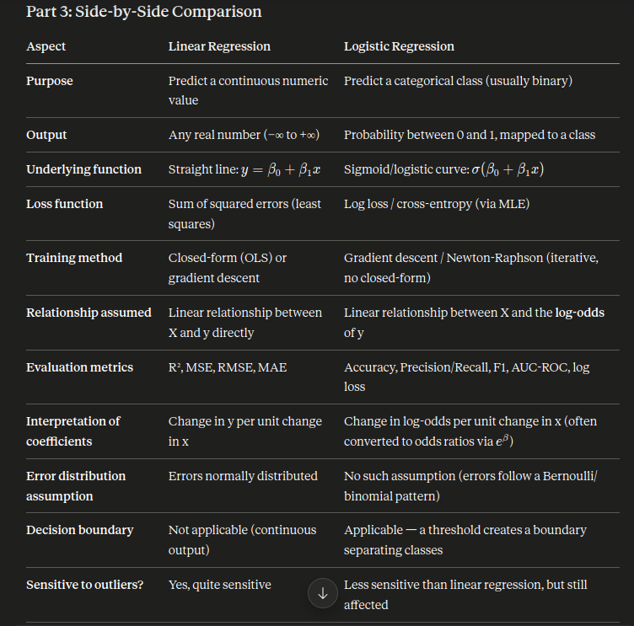

Part 4: Key Similarities
- Both are supervised learning algorithms — they require labeled training data (known outputs).
- Both are linear models at their core — logistic regression is essentially linear regression whose output is transformed via the sigmoid function. The "linear predictor" z=β0​+β1​x1​+… is common to both.
- Both estimate coefficients (weights) that show the influence/importance of each predictor variable.
- Both can handle multiple independent variables (multiple linear regression / multivariate logistic regression).
- Both are interpretable — unlike black-box models (e.g., deep neural nets), you can directly interpret how each feature affects the output.
- Both assume little/no multicollinearity among predictors for stable, reliable estimates.
- Both can be regularized — Ridge (L2) and Lasso (L1) regularization can be applied to both to prevent overfitting.
- Both belong to the family of Generalized Linear Models (GLMs) — logistic regression is a GLM with a binomial distribution and logit link function; linear regression is a GLM with a Gaussian distribution and identity link function. This is actually the deepest mathematical connection between them.

Part 5: When to Use Which — Practical Guidance

Use Linear Regression when:
- Your target variable is continuous/numeric (price, temperature, age, revenue, score).
- You want to understand how strongly and in what direction predictors affect a continuous outcome.
- You need to forecast a quantity (e.g., "how much," "how many").
- Example scenarios: predicting house prices, stock value trends (with caution), sales forecasting, predicting exam scores, estimating crop yield based on rainfall.

Use Logistic Regression when:
- Your target variable is categorical, typically binary (yes/no, 0/1, true/false).
- You care about classifying something into groups, or need the probability of belonging to a class.
- You need an interpretable baseline classification model (great starting point before trying more complex models).
- Example scenarios: fraud detection (fraud/not fraud), medical diagnosis (disease present/absent), customer churn prediction, loan default prediction, sentiment classification (positive/negative), pass/fail prediction.

Choosing between them — quick test:
Ask yourself: "Am I predicting a number, or am I predicting a category?"
- Number → Linear Regression
- Category → Logistic Regression (or another classifier)

A note on "preference" beyond the two:
- If your data violates linear regression's assumptions badly (e.g., non-linear relationships), you might prefer polynomial regression, decision trees, or random forests instead.
- If logistic regression underperforms on complex classification boundaries, you might reach for SVMs, random forests, gradient boosting (XGBoost), or neural networks — but logistic regression is almost always tried first because it's fast, interpretable, and a strong baseline.

